Village d’esclaves, Georgie, moitié 19ème

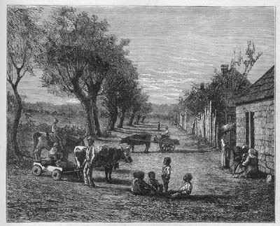
Edmund Ollier, Cassell's History of the United States, Londres, 1874-77, Vol. 3, p. 193.

http://slaveryimages.org/details.php?categorynum=8&categoryName=Plantation%20Scenes,%20Slave%20Settlements%20and%20Houses&theRecord=15&recordCount=83

