Vente d’esclaves, Nouvelle-Orléans, 1835

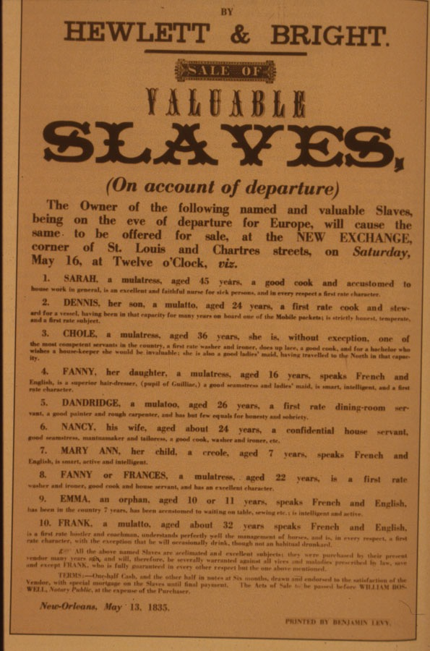
Collection de The New York Historical Society, #46628; E.D.C. Campbell & K.S. Rice (éd.), Before Freedom Came: African-American Life in the Antebellum South (Univ. Press of Virginia, 1991), fig. 100, p. 116.
http://slaveryimages.org/images/collection/large/79a_slave_sale.JPG

