Soldats noirs dans l’Union, Caroline du Nord, 1864

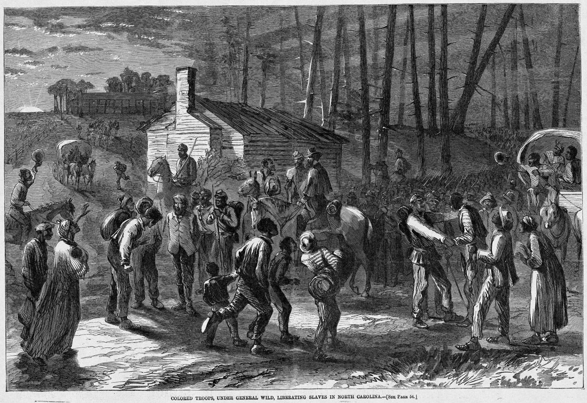
Harper's Weekly, 23 janvier 1864, p. 52.
(Copie : Special Collections Department, University of Virginia Library; et Library of Congress, Prints and Photographs Division, LC-USZ62-32314)

http://slaveryimages.org/details.php?categorynum=15&categoryName=Military%20Activities%20and%20U.S.%20Civil%20War&theRecord=7&recordCount=27

