Esclaves de maison, Caroline du Sud, 1863

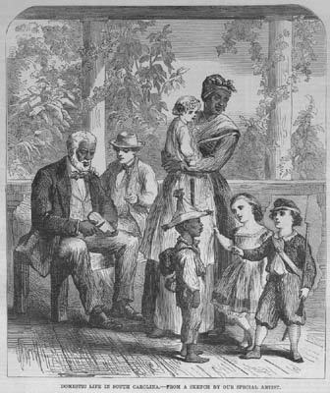
The Illustrated London News, 23 mai 1863, vol. 42, p. 552.

http://slaveryimages.org/details.php?categorynum=9&categoryName=Domestic%20Servants%20and%20Free%20People%20of%20Color&theRecord=21&recordCount=60

