Troupes noires de l’Union, Charleston, 1865

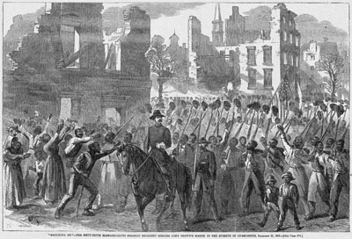
Harper's Weekly, 18 mars 1865, p.165. (Copie : Special Collections Department, University of Virginia Library)

http://slaveryimages.org/details.php?categorynum=15&categoryName=Military%20Activities%20and%20U.S.%20Civil%20War&theRecord=9&recordCount=27

