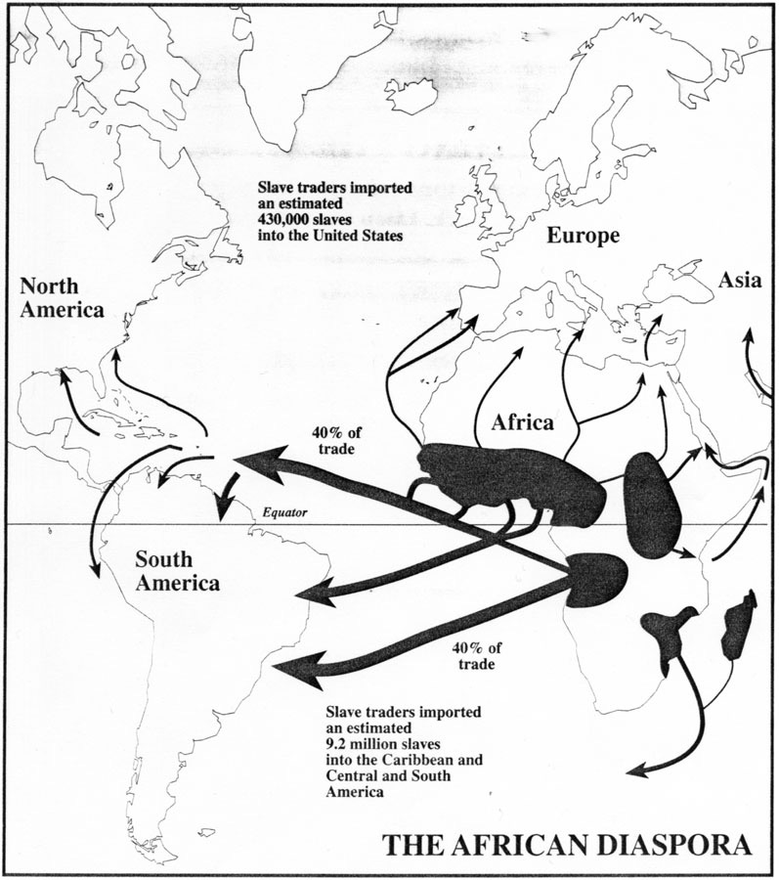
Paul Finkelman,Joseph Miller, (éd), Macmillan Encyclopedia of World Slavery (New York, 1998), vol. 1, p. 17.

http://slaveryimages.org/details.php?categorynum=1&categoryName=Maps:%20Africa,%20New%20World,%20Slave%20Trade&theRecord=30&recordCount=34

