Revendeurs d’esclaves, Virginie, 1863 ou 1865

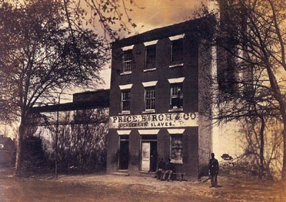
Andrew Joseph Russell, in Ellen Dugan (éd.), Picturing the South, 1860 to the Present, Chronicle Books, San Francisco, 1996, p. 33.
http://slaveryimages.org/details.php?categorynum=6&categoryName=Slave%20Sales%20and%20Auctions:%20African%20Coast%20and%20the%20Americas&theRecord=19&recordCount=75

