Vente d’esclaves

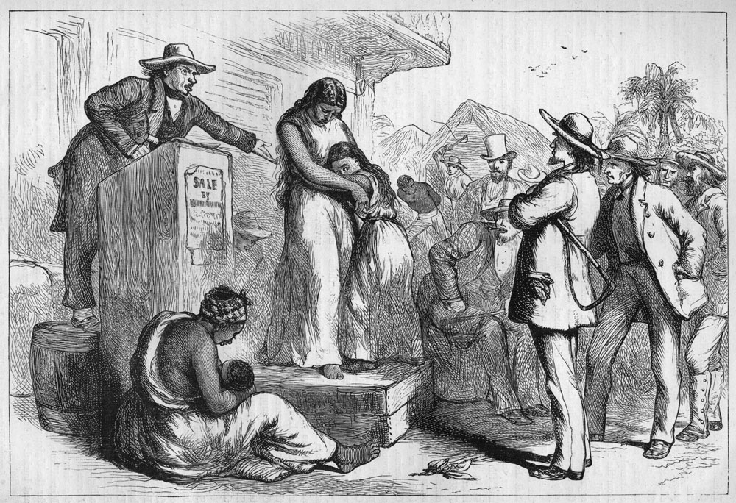

Edmund Ollier, Cassell's History of the United States, Londres, 1874-77, Vol. 3, p. 199

http://slaveryimages.org/details.php?categorynum=6&categoryName=Slave%20Sales%20and%20Auctions:%20African%20Coast%20and%20the%20Americas&theRecord=16&recordCount=75

