Maison de propriétaire, Sud, 1859

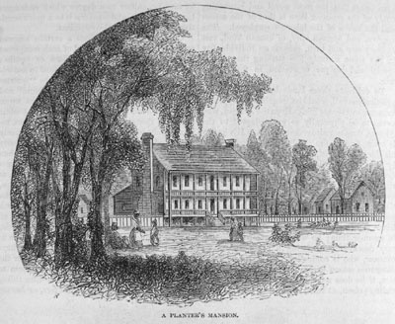
Harper's New Monthly Magazine (1859), vol. 19, p. 732; accompagne l’article de T. Addison Richards, The Rice Lands of the South (pp. 721-38). (Copie : Special Collections Department, University of Virginia Library)

http://slaveryimages.org/details.php?categorynum=8&categoryName=Plantation%20Scenes,%20Slave%20Settlements%20and%20Houses&theRecord=27&recordCount=83

