Village d’esclaves, Caroline du Nord, 1866

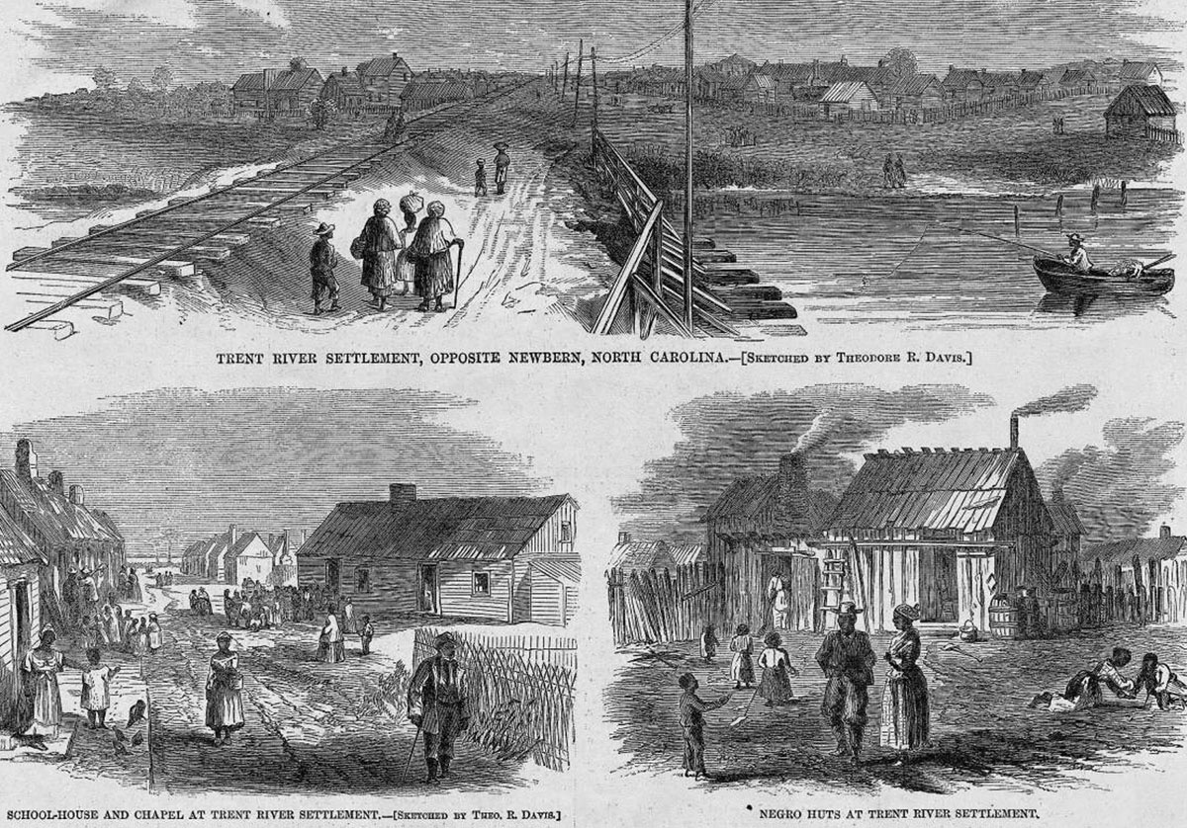
Harper's Weekly, 6 juin 1866, p. 361.
http://slaveryimages.org/details.php?categorynum=8&categoryName=Plantation%20Scenes,%20Slave%20Settlements%20and%20Houses&theRecord=24&recordCount=83

