Cannes à sucre, Louisiane, 1853

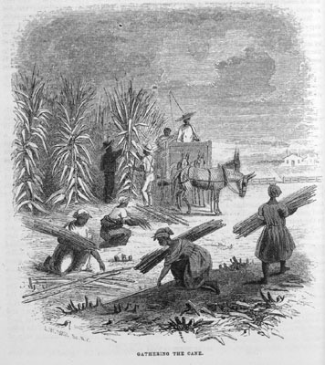
Harper's New Monthly Magazine (1853), vol. 9, p. 760. (Copie : Special Collections Department, University of Virginia Library)
http://slaveryimages.org/details.php?categorynum=7&categoryName=New%20World%20Agriculture%20and%20Plantation%20Labor&theRecord=27&recordCount=114

