Alabama, 1867

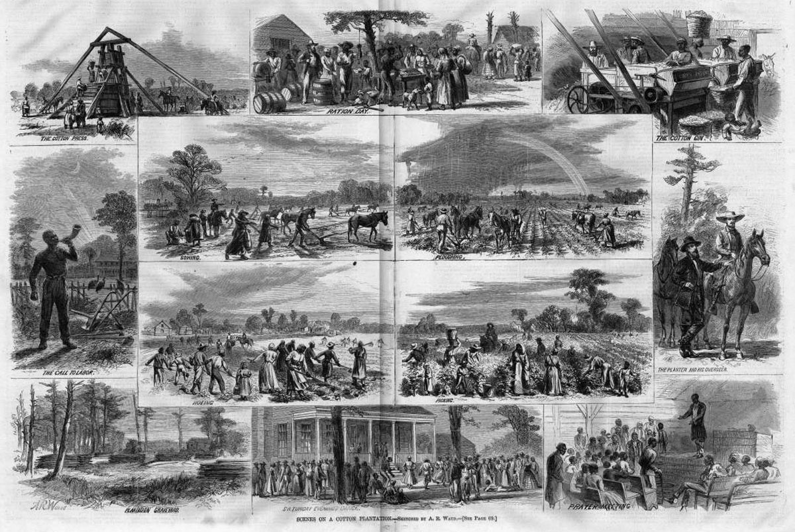
Harper's Weekly, 2 février 1867, pp. 72-73.

http://slaveryimages.org/details.php?categorynum=7&categoryName=New%20World%20Agriculture%20and%20Plantation%20Labor&theRecord=26&recordCount=114

