Maïs, 1861

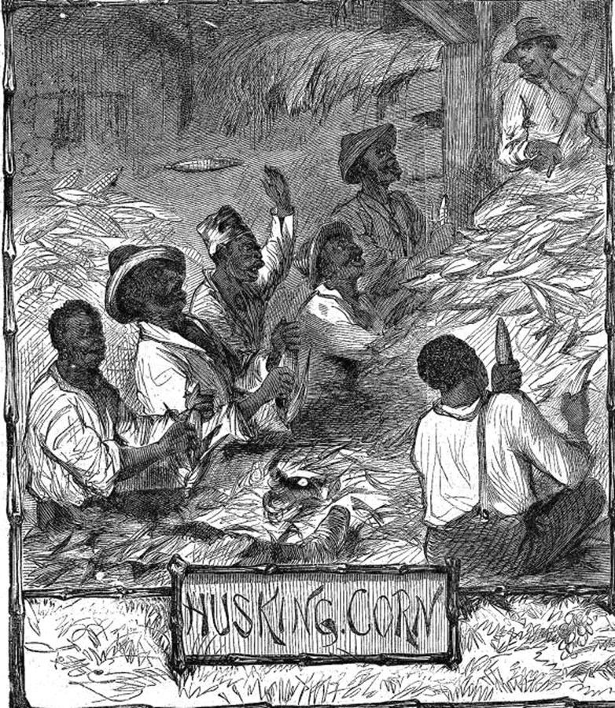
Harper's Weekly, 13 Avril 1861, p.232. (Copie : Special Collections Department, University of Virginia Library)

http://slaveryimages.org/details.php?categorynum=7&categoryName=New%20World%20Agriculture%20and%20Plantation%20Labor&theRecord=24&recordCount=114

