Plantations de coton, Mississipi, 1881

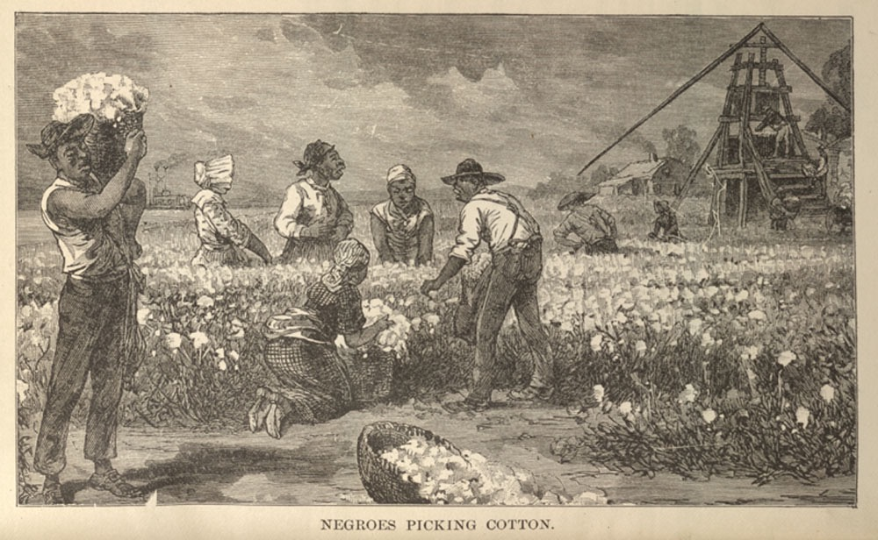
Willard W. Glazier, Down the Great River: Embracing an Account of the Discovery of the True Source of the Mississippi, Philadelphie, 1887, p. 375. (Copie : Special Collections Department, University of Virginia Library)

http://slaveryimages.org/details.php?categorynum=7&categoryName=New%20World%20Agriculture%20and%20Plantation%20Labor&theRecord=20&recordCount=114

