Culture du Coton, Sud des USA, 1875

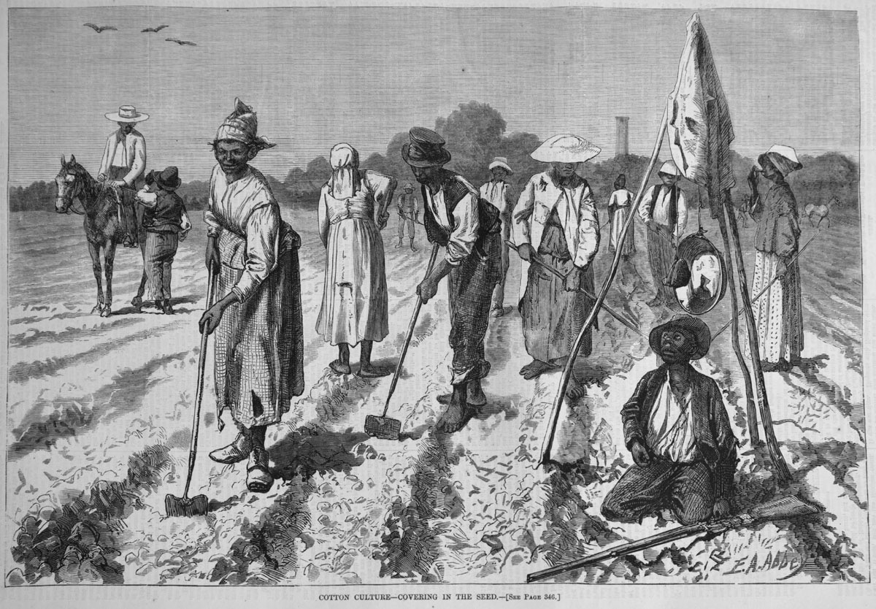
Harper's Weekly (24 avril 1875), p. 344. (Copie : Special Collections Department, University of Virginia Library)

http://slaveryimages.org/details.php?categorynum=7&categoryName=New%20World%20Agriculture%20and%20Plantation%20Labor&theRecord=14&recordCount=114

